**KIOCL Limited**

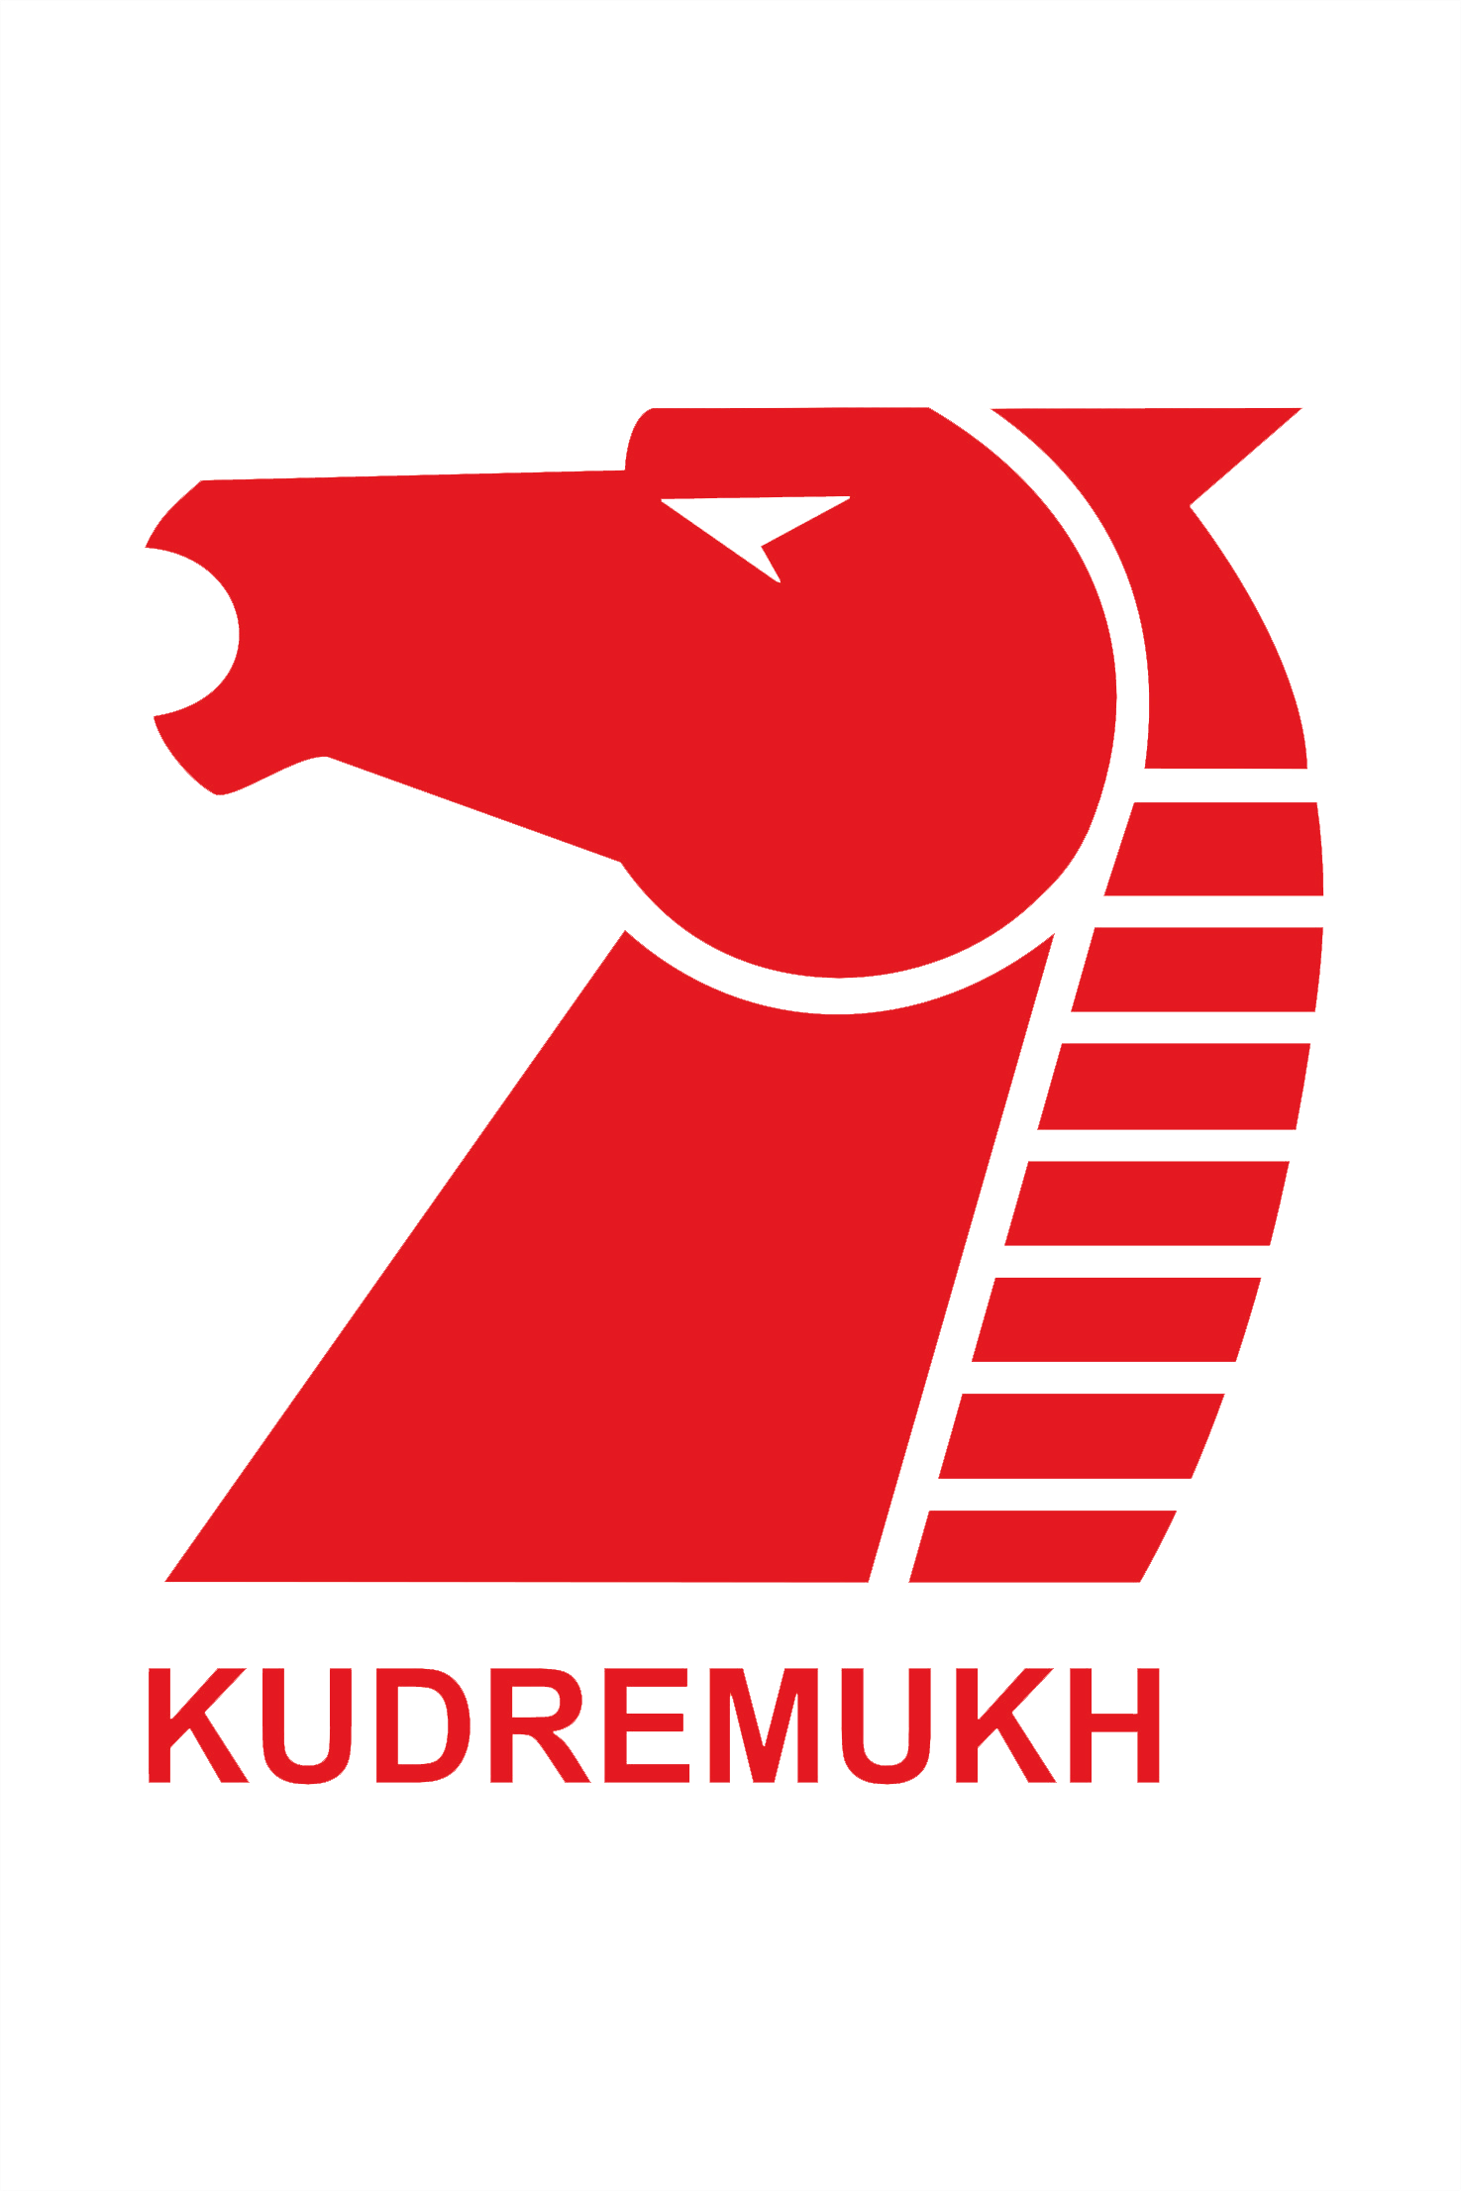

(A Govt of India Enterprise)

Koramangala II Block, Bengaluru-34

**RISK MANAGEMENT POLICY**

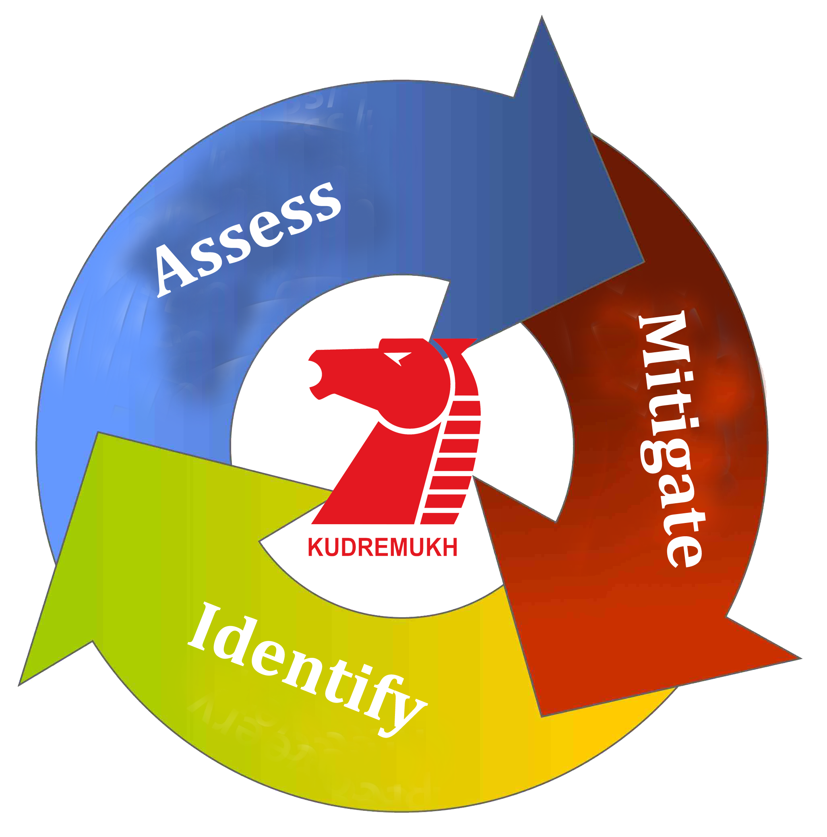

**KIOCL LTD**

**RISK MANAGEMENT POLICY**

1. **PREFACE**

* 1. The Policy sets out KIOCL Limited’s (“KIOCL” or the “Company”) system of risk oversight, management of material business risks and internal control.
  2. KIOCL recognizes that risk is inherent to any business activity and that managing risk effectively is critical to the immediate and future success of the Company.
  3. Risk Management Policy helps the organization in achieving desired performance and profitability targets and also complying with laws, rules and regulations. It helps to minimize /avoid damage to the entity and associated consequences. In the scheme of Corporate Strategies, this Policy is highly significant and forms one of the main responsibilities of the Management. Risk Assessment & Minimization should be an integral part of Corporate Management. All activities associated with this needs to be aligned to achieve the Corporate goals. It needs involvement of all departments. Suggestions from all corners for developing Risk Management Policy are welcome. This enables in updating/revising the Policy to meet the changing situations on continuous basis.

2. **POLICY ANDOBJECTIVE**

The Management Policy Statement

1. Ensure protection  of  shareholder  value  through  the  establishment of an integrated  Risk  Management  Framework  for  identifying, assessing, mitigating, monitoring, evaluating and reporting of all risks.
2. Provide clear and strong basis for informed decision making at all levels of the organization.
3. Continually strive towards strengthening the Risk Management System through continuous learning and improvement.

The objective of the Policy is to:

1. Encourage an appropriate level of risk tolerance throughout the Company.
2. Establish procedures to analyze risks within agreed parameters across the Company.
3. Establish appropriate risk delegations and corresponding risk management framework across the Company; and
4. Ensure KIOCL has a risk management framework that can noticeably respond the risk profile of the Company.

3. **RISK APPETITE**

3.1 A critical element of the Company’s Risk Management Framework is the risk appetite, which is defined as the extent of willingness to take risks in pursuit of the business objectives.

3.2 The key determinants of risk appetite are as follows:

1. Shareholder and investor preferences and expectations.
2. Expected business performance (return on capital).
3. The capital needed to support risk taking.
4. The culture of the organization.
5. Management experience along with risk and control management skills.
6. Long term strategic priorities.

3.3 Risk appetite is communicated through the Company’s strategic plans. The Board and Management monitor the risk appetite of the Company relative to KIOCL’s actual results to ensure an appropriate level of risk tolerance throughout the Company.

**4. RISK MANAGEMENT FRAMEWORK**

4.1 KIOCL believes that risk should be identified and mitigated on a continuous basis. As a result, the Company has designed a dynamic risk policy framework to allow KIOCL to mitigate its risks effectively and efficiently, enabling both short term and long term strategic and business objectives to be met.

4.2 The Company’s approach to risk assessment & mitigation is summarized below:

4.2.1 Identification of risks

To ensure key risks are identified;

* Formulated risk assessment committee.
* Defines risks in the context of the Company’s strategy.
* Documents risk profiles, including a description of the material risks; and.
* Regularly reviews and updates the risk profiles.

The Company’s Risk Profile is summarized below:

4.2.2 Assessment of risks

The Risk assessment methodology shall include:

* Colleting of information
* Identification of major risks
* Rating of each risk on the basis of
* Consequence (Impact)
* Probability (Likely hood of occurrence)
* Exposure (Effective of existing control systems)
* Prioritization of risks
* Operation-wise exercise on risk identification, risk rating, control mechanism, action and fixing up responsibility
* Program for risk level reduction plan and setting level of responsibility and accountability
* Formulation of action plan for Monitoring Risk reduction, evaluation and correction

4.2.3 Measurement and control

Identified risks are then analyzed and the manner in which the risk is to be mitigated and controlled is then determined and agreed. Generally, accepted options are:

* Accept the risk (where it is assessed the risk is acceptable or if avoiding the risk presents a greater risk through lost opportunity)
* Mitigate the risk (through controls and procedures)
* Avoid the risk (stop the activity)
* Transfer the risk (outsourcing arrangements)
* Finance the risk (through insurance)

**4.2.4** Continuous assessment

The Company’s Risk Management Framework requires a continuing cycle of implementing, monitoring, reviewing and mitigating risk management process.

**5. RISK PROFILE**

The identification and effective management of risks is critical in KIOCL’s achieving strategic and business objectives. The Company’s activities give rise to a broad range of risks which are considered under the following key categories of risk:

**5.1 Strategic Risks**

* Lack of responsiveness to changing economic or market conditions, including commodity prices and exchange rates that impact the Company’s operation.
* Ineffective or poor strategy developed.
* Ineffective execution of strategy.

**5.2 Financial Risks**

* Financial performance does not meet expectations.
* Capital is not effectively utilized or managed.
* Cash flow is inadequate to meet financial obligation,liquidity risk, rising debtors etc.,
* Financial results are incorrectly accounted for or disclosed.
* Credit, market and/or tax risk is not understood or managed effectively.
* Exchange variation
* Interest rates for investment/borrowing

**5.3 Marketing and Sales Risks**

* Inadequate sourcing of raw materials at right quality, quantity and at competitive price
* Government policies and guidelines
* Determining right Marketing policy open to different avenues and its flexibility to open market
* Sale of products at market price
* Stiff competition from domestic and abroad suppliers
* Accessibility to more customers and widening of market base
* Net positive foreign exchange earning

**5.4 Operational Risks**

* Failure to locate or identify mineral deposits.
* Failure to achieve predicated grades in exploration and mining.
* Operational and technical difficulties encountered in mining.
* Difficulties in commissioning and operating plant and equipment.
* Mechanical failure or plant breakdown.
* Unexpected shortages or increases in the costs of consumables, spare parts, plant and equipment.
* Unanticipated metallurgical problems which may affect production costs.
* Adverse weather conditions.
* Industrial and environmental accidents.
* Industrial disputes;
* Failure to meet expenditure commitments on project executions, prospecting, and exploration licensesto be obtained.
* Inadequate or failed internal processes, people and systems, including external events.

**5.5 Investment Risks**

* Failure to provide expected returns for defined objectives and risk such as underperforming to the stated objectives and/or benchmarks.

**5.6 People Risks**

* Inability to attract and retain quality and appropriate people.
* Inadequate succession planning.
* An inappropriate culture.
* De-motivating factors.

**5.7 Legal and Regulatory Risks**

* Legal and commercial rights and obligations are not clearly defined or understood; and
* Commercial interests not adequately protected by legal agreements.

**5.8 Compliance Risks**

* Non conformance with or inability to comply with rules, regulations, prescribed practices, internal policies and procedures or ethical standards.

**5.9 Reputation Risks**

* Involving risks to the public reputation of the organization and their effects.

**5.10 Cyber Risks**

* Cyber threat which can encompass all crisisat once and impact across organization in safeguarding of intellectual property, financial information and data base.

**6. PROCESS OF IMPLEMENTATION OF RISK MANAGEMENT WITH ROLES & RESPONSIBILITIES:**

**6.1 SCHEDULES FORRISK MANAGEMENT IMPLEMENTATION**:

All the departments of the Company are covered under the Risk Management. A Steering Committee consisting of HODs draws a schedule in consultation with HODs of various departments for implementation of Risk Management across the organization in a phased manner so as to make Risk Register for the Company and mitigate with the mandate and review thereafter once in a Quarter.

**6.2 ORIENTATION PROGRAME ON RISK MANAGEMENT**

An orientation program be organized on Risk Management to all the key functionaries in consultation with the HODs of respective departments as and when need arises to bring in awareness among the executives about the importance and need for Risk Management implementation.

**6.3 BRAIN STORMING SESSION:**

Brain storming session to be organized by the HODs of respective departments as and when need arises.Steering Committee on Risk Management will also associate on request from concerned HOD. The HOD and the key executives are to take active part in brain storming session to identify potential risks related to their processes, main objectives of the Department and the organization.

The HOD of the respective departments who finally short list the potential risks of his department which needs mitigation plan and identifies the Risk Champion.

**6.5 RISK PROFILES:**

Risk profiles are to be prepared by the concerned department in the prescribed format placed at **Annexure-I**. Risk profile contain vital information about the risk, contributing factors, risk treatment plan, responsibilities and target dates etc., as detailed in the annexure. The risk profile is to be signed by the RISK OWNER.

6.5.1 RISK MEMBER, RISK CHAMPION AND RISK OWNER:

The HOD of the respective department forms a small team with the concerned personnel for each risk identified and agreed. This team is responsible to monitor the risk and act as per the risk treatment plan. The team leader is called “RISK CHAMPION” and the other personnel are called “RISK MEMBERS”. The HOD of the concerned department is the “RISK OWNER”. For the purpose of Risk Management, Seventeen Departments identified viz: PP, PF, CPP, BFU, HR, Materials, Commercial, Technical Services, Business Planning, Finance, Systems, Board & Co-ordination, Projects, Health, Training & Safety, O&M Vertical and MED. These departments will have one Risk Champion each.

If the action plan under risk treatment plan is related to more than one department, the concerned members from other departments are to be co-opted by the concerned HOD in consultation with other HODs.

The “RISK OWNER” finally shortlist the potential risks of his department, mitigate, monitor and review the risks with the mandate of the Management

6.5.2 PERIODICAL REVIEWS:

The risks are to be monitored and treated by the said team under the guidance of risk champion/owner as scheduled in the risk profile. The risk owner will review all the risks identified and profiled on quarterly basis with reference to the risk treatment plan. The risk owners are required to record the minutes of such reviews and forward a copy of the same to Chairman, Steering Committee.

6.5.3 ADDITIONS/MODIFICATIONS/DROPPING OF RISKS:

There may be a situation to add/modify the risk treatment plan due to the changes in the anticipated risk including its intensity. Similarly, transfer of personnel may lead to modifications in risk profile with respect to responsibility etc. Such additions/modifications are to be carried out to the risk profile with the approval of Competent Authority as per delegation of power given here under.

In case the identified risk is totally treated and no more treatment/action is necessary, the risk can be dropped with the approval of competent authority given hereunder under delegation of power.

The information with respect to addition/modification/dropping of a risk is to be forwarded by the risk owner on approval from concerned Functional Director to the Chairman of Steering Committee for necessary record.

6.5.4 RISK REGISTER FOR THE DEPARTMENT:

A Risk Register approved by the Concerned Functional Director/Unit Head is to be maintained by the concerned department HOD in the prescribed format placed at **Annexure-II** which contains a gist of all the risks identified by the department and a copy should be forwarded to the Chairman of Steering Committee.

6.5.5 RISK REGISTER FOR THE COMPANY:

A Risk Register for the Company in the prescribed format placed at **Annexure-III** will be maintained by the Chairman of the Steering Committee with the approval from CMD. This register contains all the risks identified for the Company.

* + 1. MANAGEMENT INFORMATION SYSTEM (MIS):

IT Department will develop in co-ordination with Risk Officer, a comprehensive Risk Management System package to facilitate recording and generation of required information for submission to various internal/external authorities. Steering Committee /Risk Management Team will provide necessary inputs for this purpose. This package will be under the control of IT Department.

6.7 STEERING COMMITTEE:

A Steering Committee consists of HODs of various departments as approved by the Management for successful implementation of Risk Management. The Steering Committee will periodically (say once in 3 months) review the implementation of Risk Management across the Organization. They will guide the Risk Management Team of various departments whenever required.

6.8 CHIEF RISK OFFICER (CRO):

Chief Risk Officer for implementation of Risk Management is one of the Functional Directors as nominated by CMD and who shall oversee the establishment of Risk Management System across the organization, periodically inform the Audit Committee and Board of Directors about its implementation and coverage. CRO shall take necessary action for implementation of suggestions/directions given by the Audit & Risk Management Committee/Board on the implementation of Risk Management.CRO shall be assisted by the Risk Officer (RO) at the level of DGMand above as nominated by CMD.

**7. RISK OVERSIGHT**

The Company has laid down well defined procedures for its various activities. All the operations and transactions in the Company are carried out in accordance with applicable rules, regulations, company’s manuals and policies approved by the Competent Authorities, guidelines of Government, CVC & DPE, as may be applicable to it, so as to assess risk, if any, associated with such operation/transactions and minimize the same.

**7.1 Governance Structure**

KIOCL’s Risk Management Policy frame work is supported by the Board of Directors, Management and the Audit & Risk Management Committee.

**7.2 Board of Directors**

Board is overall responsible for framing, implementing and monitoring the Risk Management of the Company and approve the Risk Management Policy.

Subsequently, Audit and Risk Management Committee appointed by the Board has to review the Policy from time to time and approve for changes as deemed fit.

**7.3 Management**

7.3.1 To assist the Audit and Risk Management Committee / Board in discharging its responsibility in relation to risk management, the Board has delegated certain responsibilities to management.

7.3.2 Management are responsible for monitoring that appropriate processes and controls are in place to effectively and efficiently mitigate risk, so that the strategic and business objectives of the Company can be met.

7.3.3 When considering the Audit Committee’s review of financial reports, the Board receives a written statement, signed by the Managing Director and Chief Financial Officer (or equivalents), that the Company’s financial reports give a true and fair view, in all material respects, of the Company’s financial position and comply in all material respects with relevant accounting standards. This statement also confirms that the Company’s financial reports are founded on a sound system of risk management and internal control and that the system is operating effectively in relation to financial reporting risks.

7.3.4 Similarly, in a separate written statement, the Chairman of the Audit and Risk Management Committee also confirm to the Board that the Company’s Risk Management and internal control systems are operating effectively in relation to material business risks for the period, and that nothing has occurred since period-end that would materially change the position.

**7.4 Audit & Risk Management Committee**

7.4.1 The Audit & Risk Management Committee is a committee of the Board, with delegated responsibilities in relation to risk management and the financial reporting process at KIOCL.

7.4.2 The Committee is also responsible for monitoring overall compliance with laws and regulations.

**7.5 Assurance**

7.5.1 There are different levels of assurance in relation to the effectiveness and efficiency of KIOCL’s Risk Management Framework and associated processes and controls.

7.5.2 At first instance, assurance is provided from Management through Management reports and process.

7.5.3 Assurance also comes from the monitoring, oversight and reporting undertaken by the Audit Committee as well as from the independent testing, review and reporting undertaken by external audit. Independent external auditors are engaged by KIOCL to provide an audit opinion as required by law.

7.5.4 Process, surveillance, controls or other reviews are performed as required.

7.5.5 Reviews are also performed by regulators.

**7.6 People and Culture**

Having the right people and promoting an appropriate risk culture are critical to the future success of KIOCL. As a result, the Company is committed to fostering a culture of risk awareness, transparency and responsiveness.

**8. COMPLIANCE TO APPLICABLE LAW**

Company Secretary is responsible for reporting to the Board and Audit & Risk Management Committee about compliance with the provisions of Company’s Act 2013 and amendments thereof / SEBI’s listed agreement. Also to ensure that the Company complies with the laws applicable.

**9. ROLES AND RESPONSIBILITIES**

The following are the roles and responsibilities for effective implementation of Risk Management System across the organization.

|  |  |  |
| --- | --- | --- |
| Sl.No. | Roles | Responsibilities |
| 1 | Chief Risk Officer | Shall over see the establishment of Risk Management System. Inform Audit& Risk Management Committee and Board for its implementation and its compliance. Ensure providing required resources for mitigating Risk. |
| 2 | Steering Committee | Ensure successful implementation of Risk Management System in the organization. Review once in three months for continuous improvement and guide the Risk Management Team across the Organization.  Chairman of Steering Committee shall Maintain Company’s Risk Register with the approval of CMD. Based on recommendation by Steering Committee, update the Company’s Risk Register once in three months with the approval of CMD. |
| 3 | Risk Officer | Conduct Risk Awareness Programme, co-ordinate with Steering Committee and HODs for implementation of Risk Management Policy across the Organization. |
| 4 | Risk Owner | Each Department HOD is the Risk Owner and shall conduct brain storming session, identify risks, risk evaluation and indexing, short list for mitigation, nominate risk champion for each risk, get the mandate from Functional Director/CMD for the required resources, mitigate, add or delete and maintain risk register for the Department with the approval of Unit In-charge or Functional Director as the case may be. Send a copy of Department Risk Register to Chairman Steering Committee with the status of implementation once in three months. |
| 5 | Risk Champion | Assist concerned HOD in implementation of RMP, responsible for mitigating the identified risk/risks, monitor and review for continuous improvement. |

**10.0 RISK MANAGEMENT HIERARCHY SYSTEM**

|  |  |  |
| --- | --- | --- |
| **AUTHORITY** | **FUNCTION LEVEL** | **REPORTING** |
| **Audit and Risk Management Committee (ARMC)** | **Independent Directors and Functional Directors** | **To the Board** |
| **Chief Risk Officer (CRO)** | **Functional Director (FD)as nominated by CMD** | **To ARMC through CMD** |
| **Steering Committee (STC)** | **Heads of Departments as nominated by CMD** | **To CRO** |
| **Risk Officer (RO)** | **DGM and above as nominated by CMD** | **To CRO through Chairman STC** |
| **Risk Owner** | **Heads of Departments** | **Unit Head/ FD** |
| **Risk Champion** | **Technical, Projects, Materials, Finance and HR etc** | **Departmental Head** |

**11.0 DELEGATION OF POWERS:**

The following delegation is given for effective implementation of Risk Management.

|  |  |  |
| --- | --- | --- |
| **Sl No** | **Description** | **Delegation of Power** |
| 1. | Identification of potential risk, signing of risk profiles, mitigating the risks with the mandate of concerned Unit Head/Functional Director. | HOD of the respective Department. |
| 2. | Proposing for additions/modifications to risk profile, addition/deletion of risks from the department’s risk register with proper justifications and keeping updated with the approval of concerned Unit Head/ Functional Director. | HOD of the respective Department. |
| 3. | Approving for departments Risk Register, allocating resources, approving for the required resources for the individual risks, addition/dropping of identified risks with proper justification. | Concerned Unit Head/ Functional Director/CRO. |
| 4. | Approving for Company’s Risk Register from time to time and sanctioning of required resources for mitigation of overall mitigation of all the risks identified. | CMD |

**11.0 REVIEW OF POLICY**

The Audit and Risk Management Committee constituted by the Board will review the Policy from time to time to ensure it remains consistent with the Board’s objectives and responsibilities.

**12.0 PUBLICATION OF POLICY**

The Policy will be available on the Company’s website and the key features will be published in the annual report.

**CHAIRMAN-CUM-MANAGING DIRECTOR**

**ANNEXURE - I**

**KIOCL LTD**

UNIT

DEPARTMENT

RISK MANAGEMENT

RISK PROFILE

|  |  |  |  |
| --- | --- | --- | --- |
| Risk Reference No. | |  | |
| Risk Category | |  | |
| Risk Description | |  | |
| Risk Owner | |  | |
| Risk Champion | |  | |
| Risk Members | |  | |
| Date of Validation | |  | |
| Periodicity of Review | | Quarterly | |
| Contributing Factor and overall risk ranking | |  | |
| Likelihood Rating (A) – (scale of 1-5) | |  | |
| Impact Rating (B) – (Scale of 1–5) | |  | |
| Financial Exposure in the event of risk Occurrence | |  | |
| Insurance to cover Financial Exposure | | (Yes/No) | |
| Exposure Rating (C) -- (Scale of 1-3) | |  | |
| Overall Risk Indexing - (AxBxC) | | In case of overall rating is between  0 to 12 (Low risk-Green)  13 to 24 (Medium Risk-Amber)  25 and above (High Risk-Red) | |
| Existing Risk Treatment measure (if any) | |  | |
| Sl.No. | Risk Treatment Action | Target Date | Responsibilities |
| 1 |  |  |  |
| 2 |  |  |  |
| 3 |  |  |  |
| Whether documented and communicated? | |  | |
| Whether existing controls are sufficient? | | (Yes/No) | |
| Proposed Risk Treatment Plan: (If any) | |  | |
| Sl.No. | Risk Treatment Action | Target Date | Responsibilities |
| 1 |  |  |  |
| 2 |  |  |  |
| 3 |  |  |  |

Signatures:

Risk Champion Risk Owner

**ANNEXURE – II**

**KIOCL LTD**

|  |  |  |  |  |  |  |  |
| --- | --- | --- | --- | --- | --- | --- | --- |
| **RISK MANAGEMENT (RM) – MIS** | | | | | | | |
| **DEPARTMENT – WISE RISK REGISTER**  UNIT DEPT | | | | | | | |
| **Sl.**  **No.** | **Risk Profile Number** | **Description of Risk** | **Date of Risk Profile approved** | **Risk Owner / Champion** | **Risk Contributing Factors** | **Risk Treatment Plan** | **Status** |
| 1  2  3  4  5 |  |  |  |  |  |  |  |

**ANNEXURE – III**

**KIOCL LTD**

|  |  |  |  |  |  |  |  |  |
| --- | --- | --- | --- | --- | --- | --- | --- | --- |
| **RISK MANAGEMENT (RM) – MIS** | | | | | | | | |
| **MAIN RISK REFISTER** | | | | | | | | |
| **Sl.**  **No.** | **Dept** | **Risk Profile Number** | **Description of Risk** | **Date of Risk Profile approved** | **Risk Owner / Champion** | **Risk Contributing Factors** | **Risk Treatment Plan** | **Status** |
| 1  2  3  4  5 |  |  |  |  |  |  |  |  |

**Risk Management Implementation - Responsible Persons**

|  |  |  |  |
| --- | --- | --- | --- |
| Sl.No | Roles | Nominated | Name |
| 1 | Chief Risk Officer | Director (Commercial) | MV Subba Rao |
| 2 | Risk Officer | JGM I/C (Materials) | T Saminathan |
| 3 | Steering Committee |  |  |
|  | Chairman  Member  Member  Member  Coordinator  Member  Member  Member | GM (P, BPD)  JGM I/C (Materials)  JGM I/C (Production)  JGM (Commercial)  JGM (Materials)  AGM (F&A)  DGM (CP&TS)  Company Secretary | BP Pal  T Saminathan  S Govindaraja Bhat  K Jayakumar  Vijayakumar C A  C S Shashi  Noor Ahmed  SK Padhi |
| 4 | Risk Owner – All HODs |  |  |
|  | Pellet Plant (PP) | JGM (PP) | Devananda Pai |
|  | Filter Plant (PF) | DGM (PF) | Ramakrishna Rao H |
|  | Captive Power Plant (CPP) | JGM (Skill Development, CPP & T&S) | AV Srinivasa Bhat |
|  | Blast Furnace Unit (BFU) | JGM I/C BFU | P Bharathraj Alva |
|  | Human Resources (HR) | GM (HR) | S Rajendra |
|  | Materials (Purchase, I&P,Stores) | JGM I/C (Materials) | T Saminathan |
|  | Commercial | JGM (Commercial) | K Jayakumar |
|  | Technical Services | DGM (CP&TS) | Noor Ahmed |
|  | Business Planning | JGM (BPD) | KV Bhashkara Reddy |
|  | Finance | JGM (Finance) | Soumen Das Gupta |
|  | Systems | AGM (Systems) | T Krishna Bhat |
|  | Board & Co-ordination | Company Secretary | S K Padhi |
|  | Projects - Kaliapani | AGM (Opn) | PK Rao |
|  | Health | CMO | Dr.M Ramappa |
|  | Training & Safety | JGM (Skill Development, CPP & T&S) | AV Srinivasa Bhat |
|  | O&M Projects, Donimalai | GM (Donimalai Project) | Roque D’ Souza |
|  | Mineral Exploration (ME) | JGM (MED) | Parameshwar Sharma |